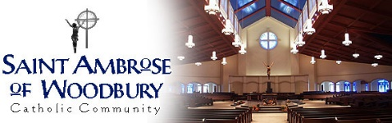

First Communion Mini Session
Includes 30 Minute session, online gallery and editing/retouching of 10 or more images
Item | Qty. | Price
 | 7.125% Sales Tax: | $
 | Total: | $

Items Available:

Item | Description | Price
Package A | 4 4x6, 2 5x7, 1 8x10 | $100.00
Package B | 2 8x10, 2 5x7 | $100.00
1 | 2 4x6 | $ 8.00
2 | 1 5x7 | $ 8.00
3 | 1 8x10 | $ 12.00
4 | Digital Image | $ 25.00

Customer Information:
Name: __________________________________________________
Address: ________________________________________________
City: ______________________ State:_________ Zip:___________
Phone: __________________________________________________
E-mail: __________________________________________________

*Please make checks payable to Woodbury Picture Perfect*
-or-
Name on Credit Card: _____________________________________
Credit Card Number: ______________________________________
Exp: _______/_______________ CVV:_________

**A portion of the proceeds will be given back to St. Ambrose**

