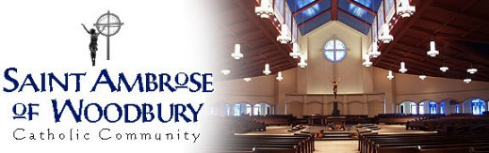
First Communion Group Pictures
Item | Qty. | Price
 | 7.125% Sales Tax: | $
 | Total: | $

Items Available:
Item | Description | Price
1 | 2 4x6 | $ 8.00
2 | 1 5x7 | $ 8.00
3 | 1 8x10 | $12.00
4 | Small Memory Mate* | $24.00
5 | Large Memory Mate* | $28.00
6 | Digital Image with Release | $25.00

Customer Information:
Name: _________________________________________________
Address: ________________________________________________
City:______________________ State:_________ Zip:___________
Phone: __________________________________________________
E-mail: __________________________________________________
Child Name:______________________________________________
Mass Date & Time: _______________________________________
Please make checks payable to Woodbury Picture Perfect
And send to: 10753 Maple Blvd
Woodbury MN 55129

-or-
Name on Credit Card: ____________________________________
Credit Card Number: ______________________________________
Exp:_______/_______________ CVV:_________

*These options will require an individual picture of your child
**A portion of the proceeds will be given back to St. Ambrose**

